Press email for scientific contacts: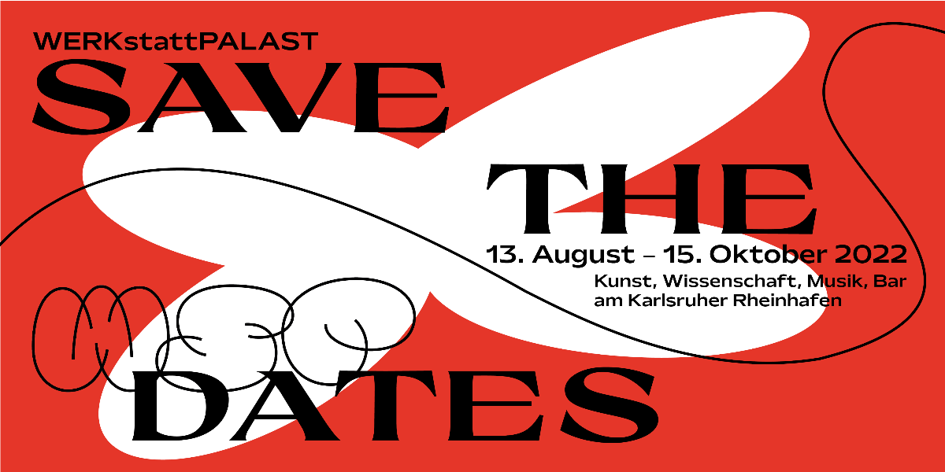
Invitation to the preview of the art and science festival WERKstattPALAST on Friday, Aug. 12, 2022, starting at 6 p.m. in Karlsruhe's Rhine Harbor. Graphic: Emma-Lilo Keller
IT IS SOON!__……………………..

Dear Ladies and Gentlemen
dear friends of art and science
dear press contacts,
On August 13th, 2022, the WERKstattPALAST will open its doors in Karlsruhe.
10-week art and science festival that will unfold its charm in the industrial area of the Rhine harbor.
We would like to invite you to our preview event on Friday, August 12th, starting at 6 pm at the Rheinhafen in Karlsruhe.
For a whole 10 weeks, from mid-August to mid-October, we will place a flying architecture in the harbor and thus show how this harbor is made accessible to an urban society. From a variety of perspectives, we treat the topic of (infra-)STRUCTURE.
You can expect insights into 30 artistic positions (from Baden-Württemberg and all over Germany), a continuous music program, workshops, dialogues and an emerging network. On-site catering will be managed by DeliBurgers. This is a Karlsruhe-based company known for processing sustainable and regional products.
The WERKstattPALAST is coordinated by two very different regional partners: the KIT Innovation Hub (Karlsruhe Institute of Technology), led by Prof. Andreas Gerdes, which advocates for more sustainable infrastructures, and ato, an art platform that calls for change in the art system (Berlin and Karlsruhe).
The project is conceived and directed by Norina Quinte.

All partners share the firm conviction that, after two years of pandemic, we can enter into an interdisciplinary exchange in order to develop future-oriented perspectives. It is important to both actors to open up the Rheinhafen in Karlsruhe in terms of cultural policy and to establish it as an area where art and culture meet science and industry.

Become part of the network and open the WERKstattPALAST 2022 with us.
Due to the unpredictable Corona situation, we would appreciate a short registration by mail to werkstattpalast@ato.vision.

All participating actors (approx. 80 people) as well as selected media representatives will be present.
The official opening will take place the following day, August 13.
ADDRESS:
An der Anlegestelle
76189 Karlsruhe
PROGRAM (12th of August 2022):
6 pm: Admission
7 p.m.: Welcome and impulse
Dr. Susanne Rockweiler, Norina Quinte, Prof. Andreas Gerdes, Christina Becker
8 pm: Concert by Fred & Luna
Afterwards: Vinyl by Super Venus and Sebastian Heck

www.werkstattpalast.de
13.08. until 15.10.2022
Program to be found online beginning 20.07.2022.

We look forward to welcoming you on 12th of August, 2022. Should you wish to publish an announcement or interview before the opening, we are always available for queries.

Norina Quinte
quinte@ato.vision
or
Christina Becker
christina.becker@kit.edu
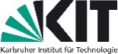
0163

